**SAVEETHA INSTITUTE OF MEDICAL AND TECHNICAL SCIENCE**

**DEPARTMENT OF COMPUTER SCIENCE AND ENGINEERING**

**LIST OF EXPERIMENTS**

**COURSE CODE: CSA11**

**COURSE NAME: Object Oriented Analysis and Design**

**1.Develop a system using UML for Passport Management System; it should verify the passport details of the applicant by the central computer. The details regarding the passport will be provided to the central computer and the computer will verify the details of the applicant and provide approval to the office. Then the passport will issue from the office to the applicant.**

**Aim:** To develop a system using UML for passport Management system and verify the passport details of the application.

**Problem Statement:** Develop a system using UML for Passport Management System and verify the passport details of the applicant by the central computer. The details regarding to verify the details of the applicant and provide approval to the office and passport will issue from the office to the applicant.

**CLASS DIAGRAM:**

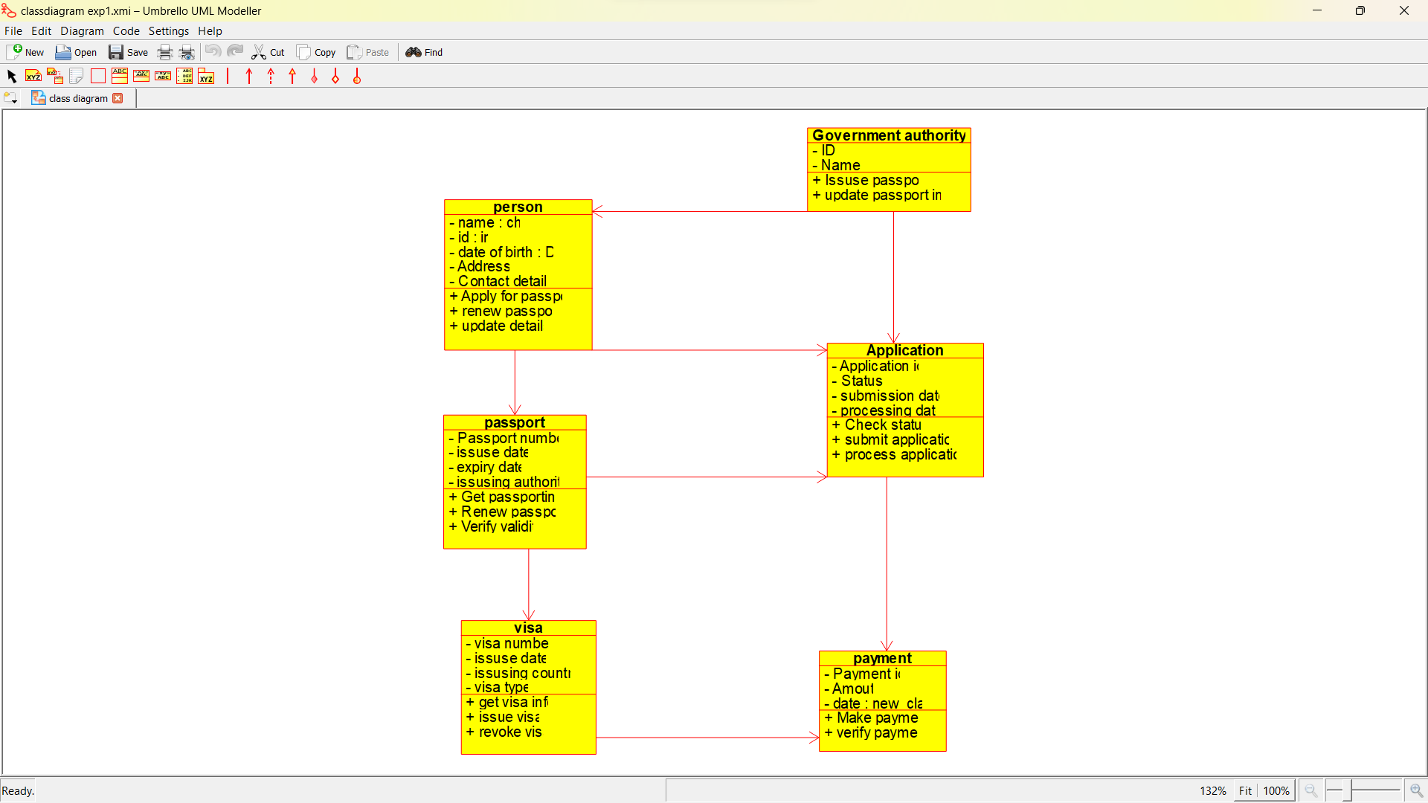

**CLASS DIAGRAM OF PAYMENT PROGRAM:**

**#include "payment.h**

**// Constructors/Destructors**

**//**

**payment::payment () {**

**initAttributes();**

**}**

**Payment::~payment () { }**

**// Methods**

**//**

**// Accessor methods**

**//**

**// Other methods**

**//**

**Void payment :: init Attributes () {**

**}**

**USE CASE DIAGRAM:**

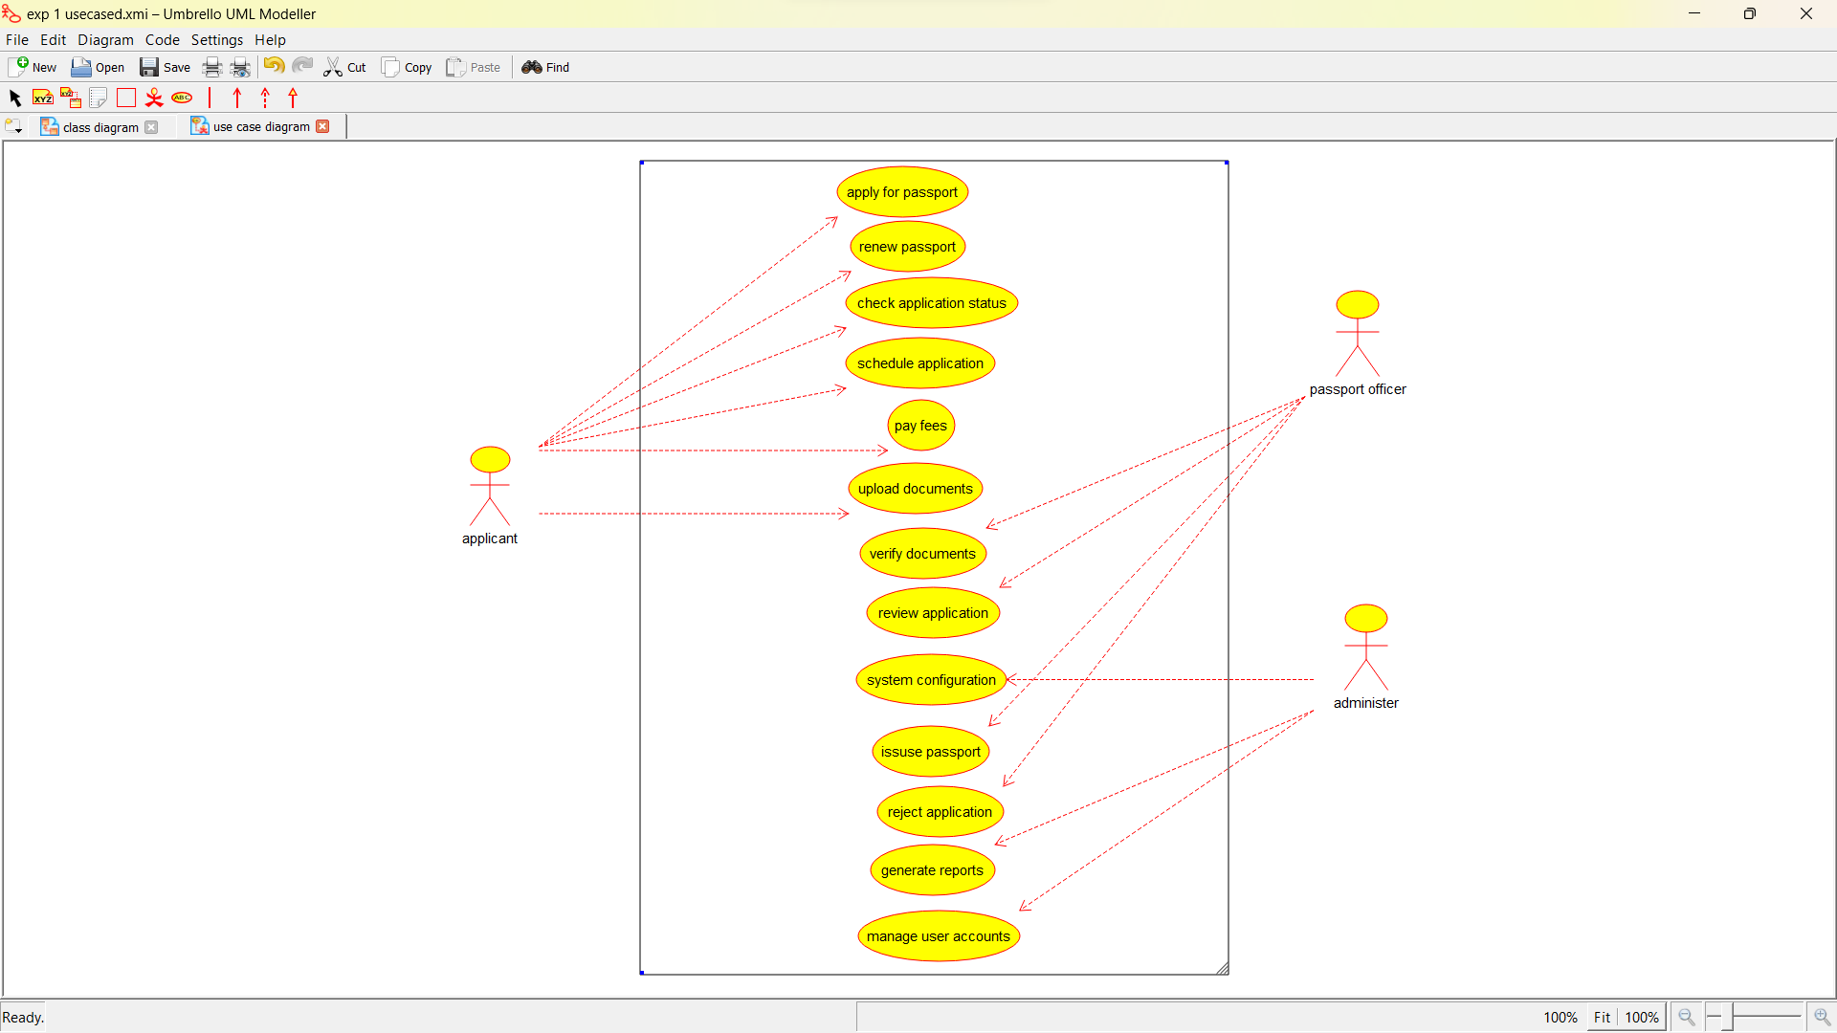

**SEQUENCE DIAGRAM:**

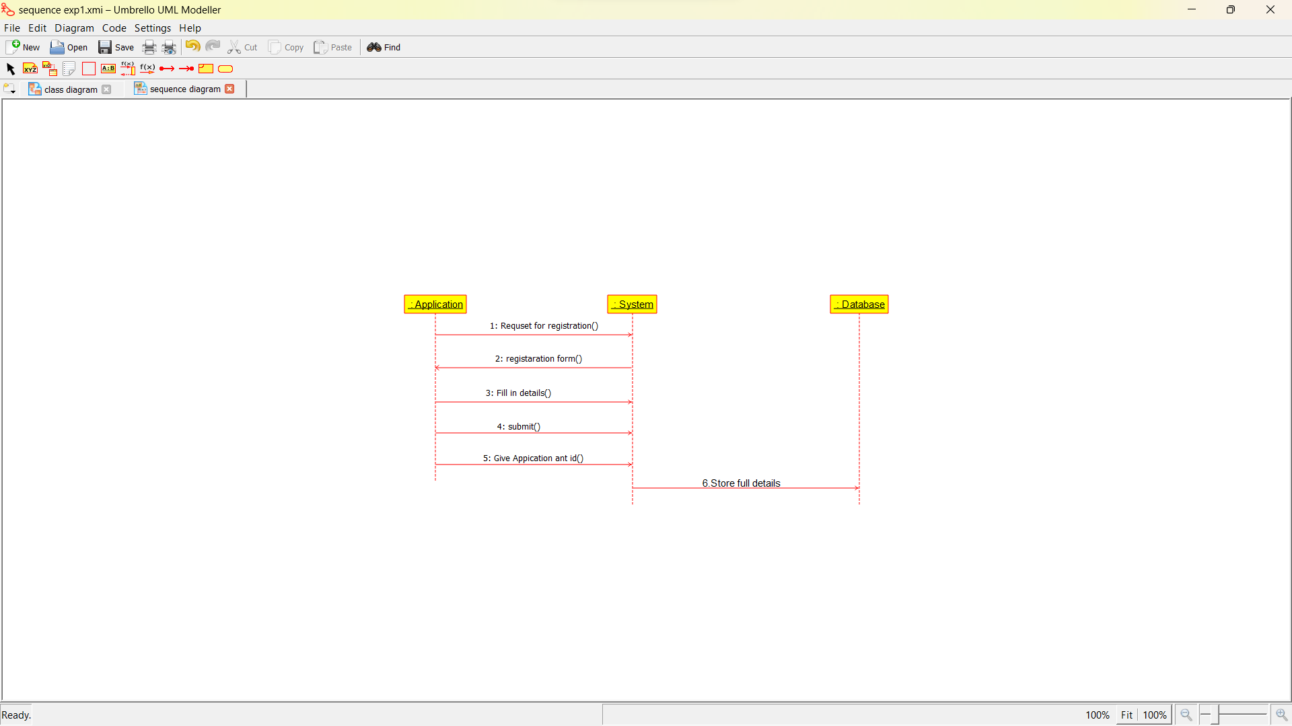

**COLLABORATION DIAGRAM:**

**ACTIVITY DIAGRAM:**

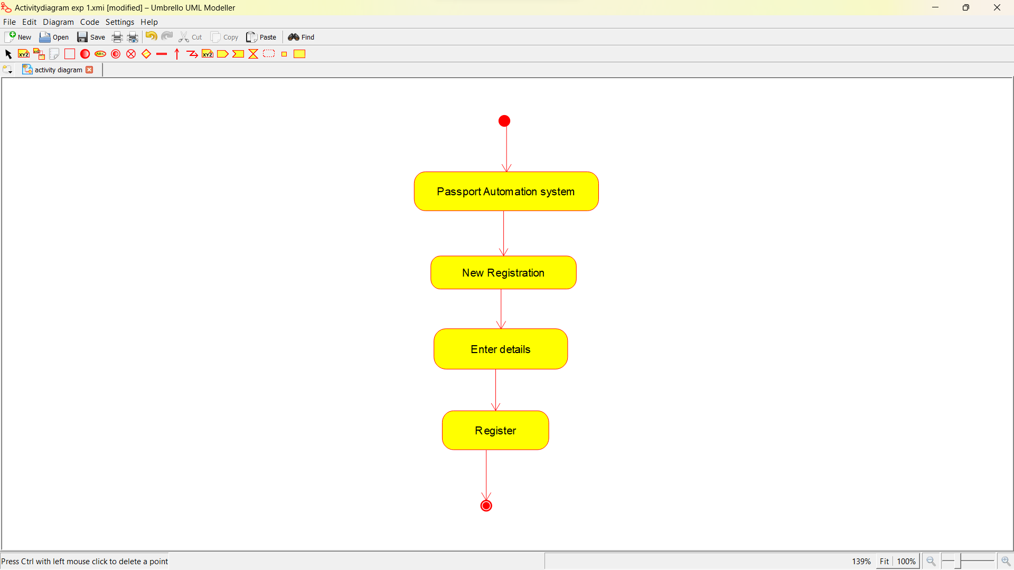

**STATE CHART DIAGRAM:**

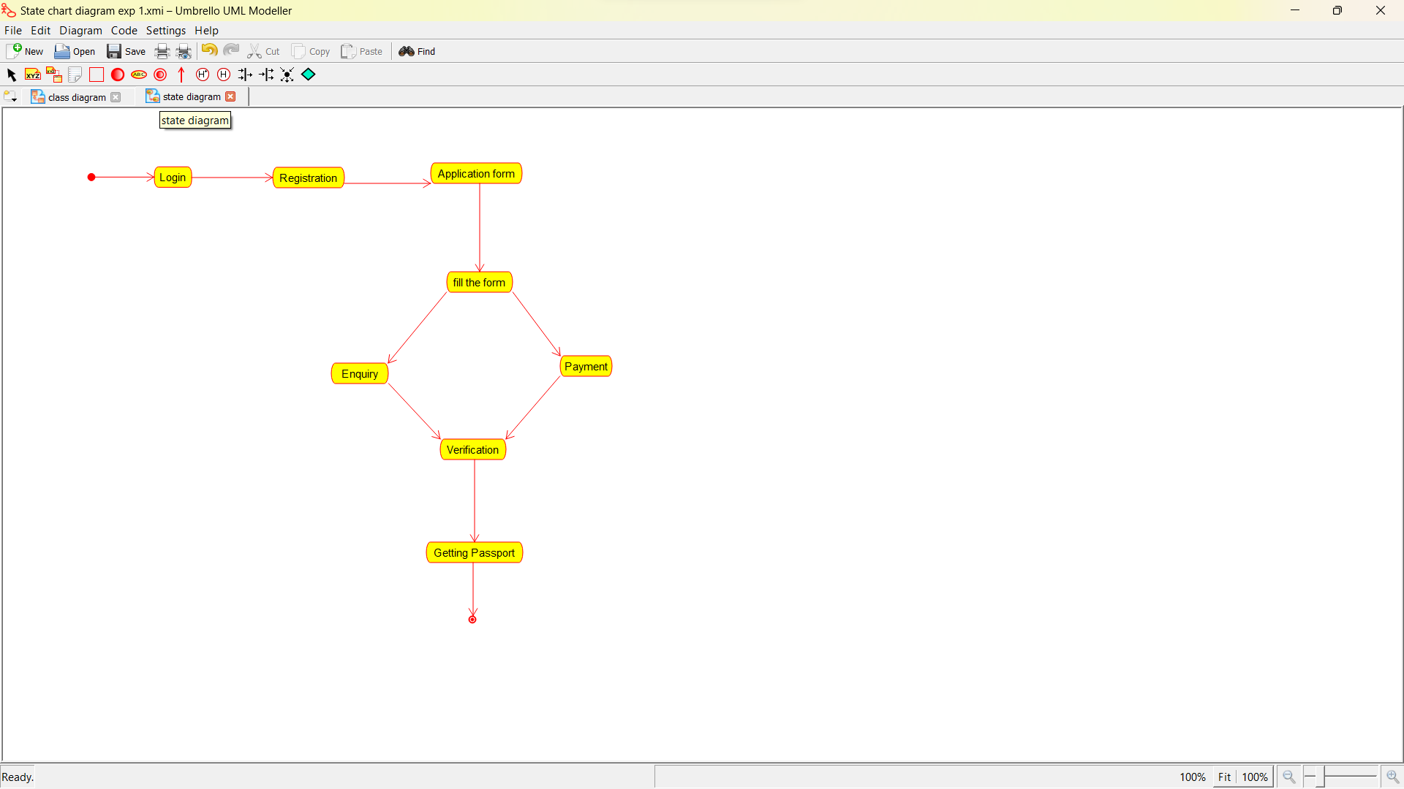

**COMPONENT DIAGRAM:**

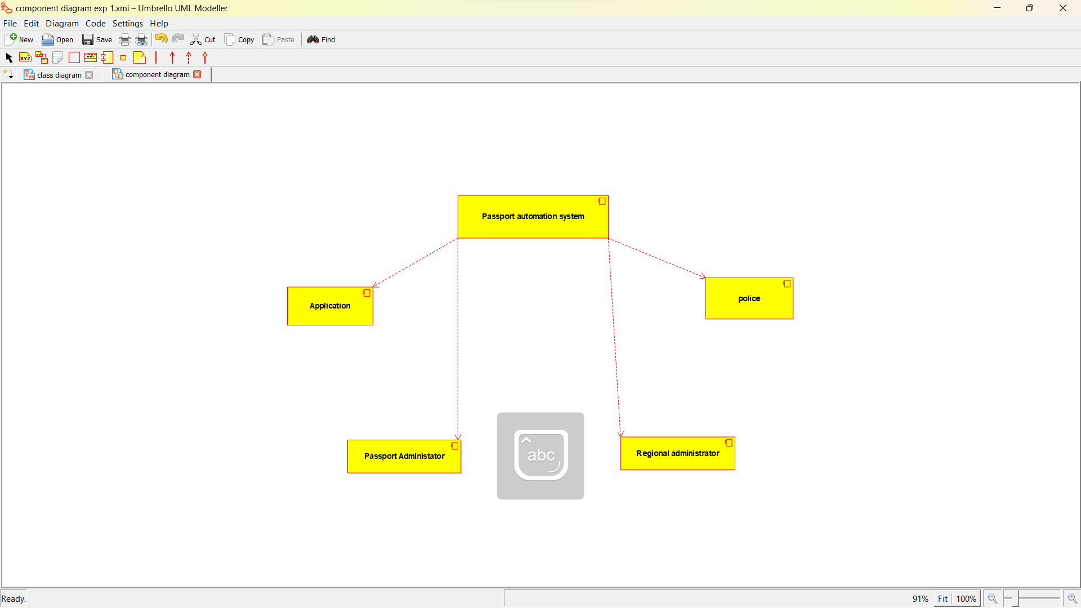

**DEPLOYMENT DIAGRAM:**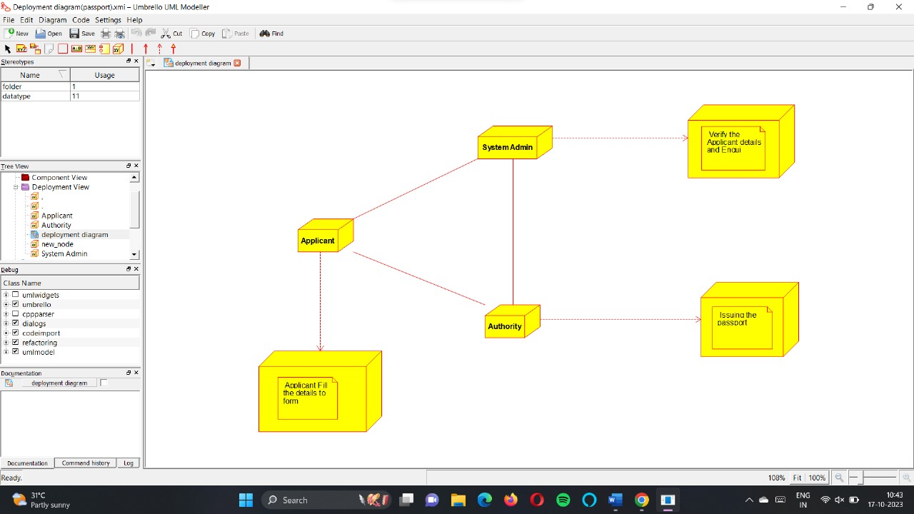

**2.Develop a system using UML for implementing the Book Bank process. It should verify the details of the student by the central computer. The details regarding the student will be provided to the central computer through the administrator in the book bank and the computer will verify the details of the student and provide approval to the office. Then the books that are needed by the student will issue from the office to him.**

**AIM:**

**Problem Statement:**

**CLASS DIAGRAM:**



**CLASS DIAGRAM PROGRAM:**

#include "Book.h"

// Constructors/Destructors

//

Book::Book () {

initAttributes();

}

Book::~Book () { }

//

// Methods

//

// Accessor methods

//

// Other methods

//

void Book::initAttributes () {

}

**USE CASE DIAGRAM:**

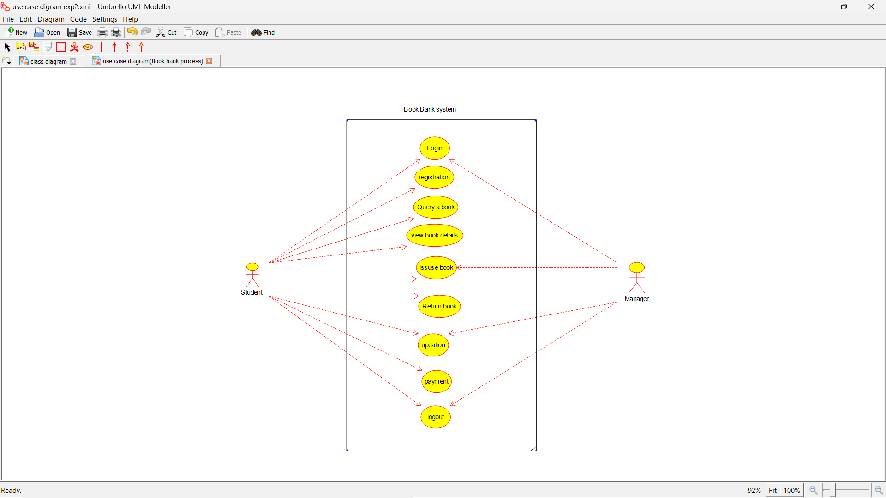

**SEQUENCE DIAGRAM:**

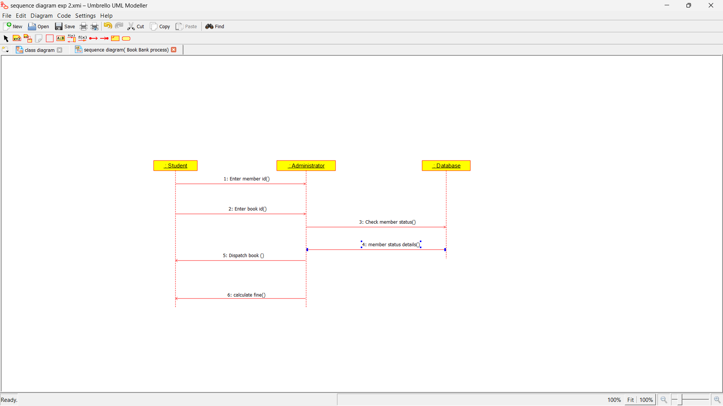

**COLLABORATION DIAGRAM:**

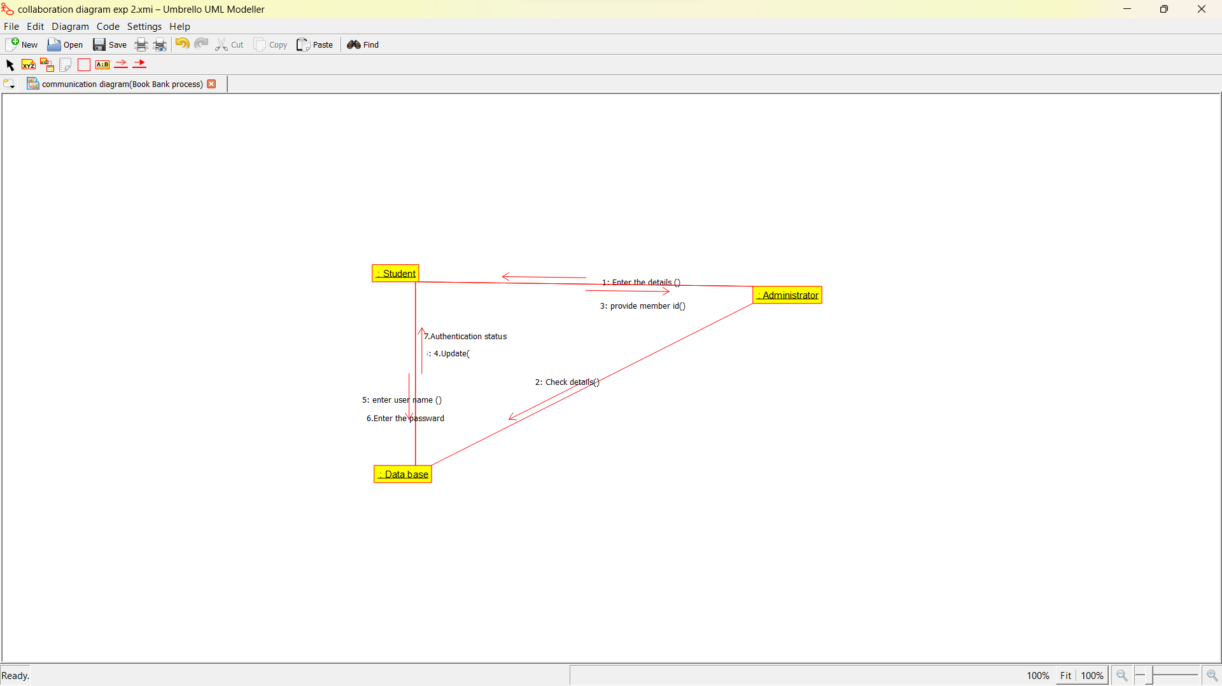

**ACTIVITY DIAGRAM:sss**

